First slide should be a dedication with the words “DEM ANDENKEN MARIUS’ VON JÖHNDAL”, in immitation of Diels’ dedication to Jagić in his Altkirchenslavische Grammatik, with a picture of Marius that implies he’s dead (which functionally he is)

What does TOROT give us?
- Lemmatisation that aims to be as fine-grained as the dictionary and is thus “form” rather than “meaning” based
- 10-place morphology tag that (almost) contains enough information to specify the “form” of each word as determined by the grammar, i.e. strength-marking on adjectives and participles, tense-tags that distinguish aorist from imperfect and future etc.; also “form” rather than “meaning”-based (genitive-accusatives marked as genitives, for example).
- Certain things like the short and long-form imperfects of быти are underspecified but can easily be inferred from the form of the word

Why can’t we rely on TOROT lemmatisation?
- doesn’t mark palatal /ń ĺ ŕ/ unless followed by jotated Cyrillic letters
- hides too much shit under Cyrillic <и>

TITUS - commits extremely heinous crimes - no online text is better than inaccurate ones
Screenshot that bit of the TITUS website that mentions planning to allow searches based on “sound-categories” (DONE, see below), and say that an LCS index is the ONLY way to do that, because the raw-letters of a text are not reliable indicators of the underlying sound-class

- Draw a diagram/spectrum of low-to-high level linguistic analysis, put textual-criticism and “textology” at one end, “pragmatics” at the other end, then TOROT/PROIEL somewhere in-between and say “here you can allow sloppiness in the exact forms of things as long as roughly the lemmatisation means the same thing and the morphology-tags are syntactically correct, but that is still too loose a relationship of actual concrete form with annotations”.
- Why go through all the effort to manually build and annotate a corpus at that level of analysis, when it allows such sloppiness, when you can just from the start take advantage of all the knowledge we already have (lexicographic analysis contained within the dictionaries, etymological data in etymological dictionaries, etc.) and build a corpus which is a solid basis for all levels of linguistic analysis, from phonology and orthography upwards?
- Thanks to the efforts of people like Kempgen who’ve added Glagolitic and weird Cyrillic characters to the Unicode standard, and made fonts for them like Bukyvede, there’s no excuse for “Handschriftferne” representations anymore, even Cyrillic transcription should be viewed with suspicion nowadays

Aim with lemma reconstructions is to be AT LEAST as rigorous as the 2 dictionaries (esp. SNSP, since SJS has a rather more cavalier attitude to the jers)

Ease of searching - I can find any example given in scholarly works basically instantly if it is correctly reconstructed, because I don’t need to worry about what particular letters are used for OCS or punctuation or spelling problems, e.g. Koch p.345 Zogr. 2sg. imper. “usěce” comes up instantly when I search “usěki”

Inflection-table generator
- mention the root-, S-, and secondary-S-aorists and things like жахъ being generated as a theoretical S-aorist of *žeg-ti and logical consequence of forms like пробасъ (turns out bastard Koch also cites žaxъ, and yet I generated it totally ignorant of any attestations of it)
- show weird conjugations like dǫti, natruti, pluti, pĺьvati (52_abl) as examples of how powerful my inflection-system is - use *rti verbs as an example where my inflection-table aorist 2,3sg might look weird but regex-searching for ŕ̥$ does in fact show a bunch of these forms ending in syllabic ŕ̥ across a wide range of mss. 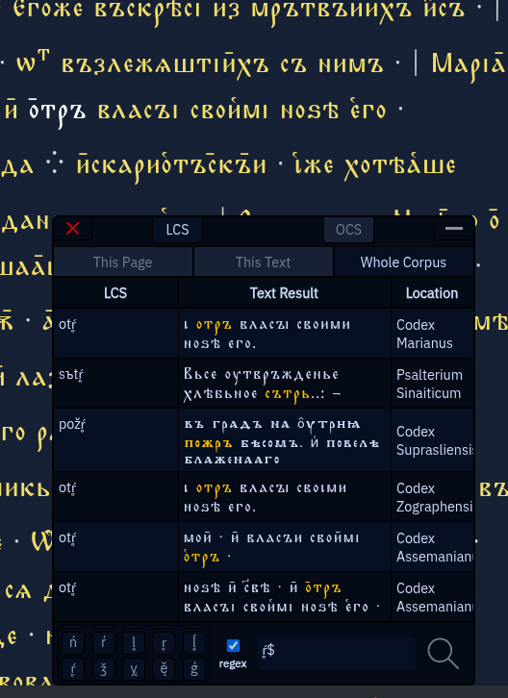

Automatic conversion of OCS into Old Russian - do Psal., or search for *meržǢ on Zogr. and follow the link to pg. 2 of John 21 and convert that as a demonstration of wholly automatic tagging + autoreconstruction + conversion to OR. (Search for the regex “^a|[ęǢ]” on that page to make the words pulsate green, then run the russifyOCS() function a few times over to show the stochastic nature of the front-nasal spellings, then search for the same regex on the first page of Uspenskij Sbornik and point out how similar the fake OR is to the real)

Problems
- Doublets which aren’t differentiated in lemmas (замѫдити/замоудити, рѫковѧть/рѫкоѩть, црькъі <*kŕ̥ky vs ціръкъі <*kirъky)
- Господя господю / зверя (jo-stem extensions) - bastard van Wijk’s article on господь
- Clitics - marked in the lemma-spreadsheet, but not yet included in autoreconstructions of texts or the search-mechanism (though adding such functionality would be trivial)
- Accentology - needed to explain spellings in certain varieties like OR (ровный рало), and could be added for those roots whose accent-paradigms are well-established, but not fesaible to do comprehensively because of all the loanwords and derivations for which no firm accentological data can be deduced

Assemanianus
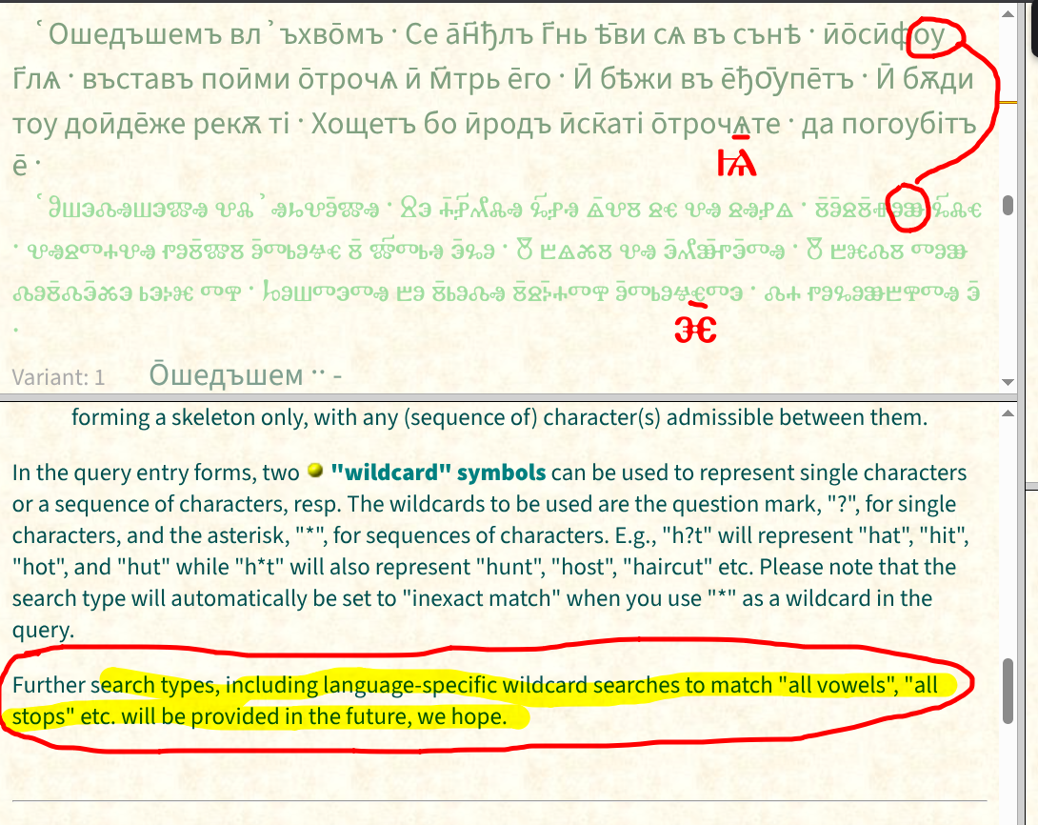

The grammar responsible for producing inflected LCS forms that match the attested OCS forms acts like an extreme form of accountability: the correctness of the grammar is literally just the percentage of forms it correctly reconstructs (assuming all morphology tags are correct): отъ плодъ моихъ познаваеши мѧ

Gorazd scraping
- Easier to use than the official website because it automatically tests for things like reflexives (e.g. мѫжати, шѧтати) or numbered variants (родъ1 etc.)
- Clicking on words uses their TOROT lemmatisation to look up, which sometimes doesn’t work because TOROT omits palatalisation-diacritics, but for lemmas which I’ve reconstructed all that information is available and I could easily convert my lemma-reconstruction into the dictionary-lemmatisation, further easing the learning-process for students unfamiliar with the normalisation-convention of the language

Possible quick easy case-studies:
- Testing the claim cited in this Vasmer entry: 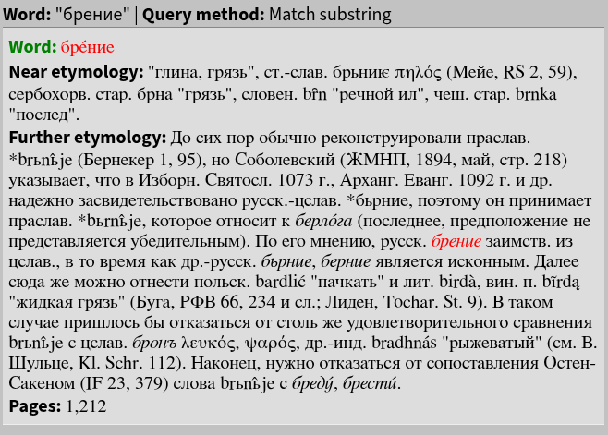
бренье shows up with this seemingly vocalised <е> spelling twice in Psal. (бреніѣ, бренье) vs 1X бръньѣ, and the same thing occurs 1X in Marianus, which if Sobolevsky’s *bŕ̥nьje theory was correct we’d have to put down to graphemic confusion between <ь> and <е> caused by vocalisation of strong *ь to /e/ in this text (already unlikely given the overwhelming tendency to spell all syllabic-liquids in this text with back-jer). Searching for spellings of the брьние lemma was something you could do just with the normal TOROT lemmatisations, but what you couldn’t do until now is easily search Psal. for all occurences of *ŕ̥: when we do that we find that nowhere at all is this group spelt with <ре>, it’s virtually always <ръ>, with two bare-liquid тврдъ and съмрті spellings. The same is true of the Marianus: the only <ре> spelling that turns up in a search for *ŕ̥ is брение, so the chance of Sobolevsky’s reconstruction being correct is tiny. We can also then check to see how other strong TRьT groups are spelt in Psal. Sin. using this regex “[tŕrpsšdfgћђklĺzžxčvbnńmǯ]rь[tŕrpsšdfgћђklĺzžxčvbnńmǯ]+[ьъ]” (obviously convenience-functions could and should be made to allow the user to do these kinds of searches without manually entering regexes), and lo and behold this does gives us <ре> spellings: поскрежьштетъ, вьскресъ etc
- Totomanova’s theories about jers after palatals
- Jagic’s jer-umlaut
- Velcheva’s Assemanianus article
- nasal in the ending of hard-stemmed Nsg. nt./masc. PRAPs

Section at the end on technical aspects:
- Though this is a website, I prefer not to think of it as such, because really it is a C++ program that happens to use the browser as its GUI. Not only am I not using any kind of web-framework (cf. TOROT and Syntacticus which use Ruby on Rails), I’m not even using a web-server (e.g. Apache, nginx); it is its own web-server.
- I.E I do all the socket-communication, HTTP-parsing, cookie-handling (to remember which page of which text you were on) etc. from scratch
- Only dependencies are sqlite3, ICU (International Components for Unicode) and libcurl (the latter only for webscraping the Gorazd dictionaries), which are so fundamental to computing they are included in the base Arch Linux install
- Much easier to manage than the hundreds and hundreds of “gems” required to get the PROIEL application to work, any of which could die at any time
- My database-functions are written directly with SQLite’s C/C++ interface, so I have complete control and can do things like add an indexed trigrams-table of the LCS forms, so that the equivalent of wildcard searching (WHERE form LIKE ‘%query%’;) can be done using the index and don’t require a full table-scan comparison of every row, meaning queries should be just as fast no matter how large the corpus of texts grows

